Tables game
This activity will help your child to recall multiplication facts up to 10 × 10.
You will need a pack of playing cards, without the picture cards (ie. Jacks etc.)
- Take turns to reveal two cards.
- Try to multiply the numbers together.
- Ask your partner to check if you are correct.
- If you are correct you score points to match the tens digit of the answer.

For example:
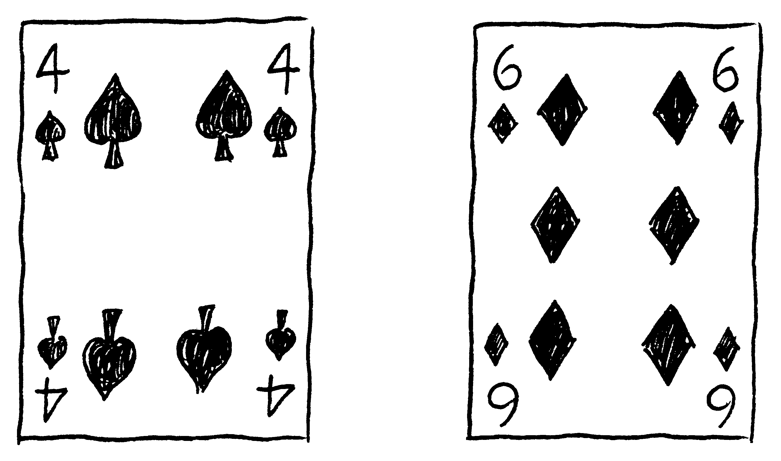

4 x 6 = 24 ✓

- If the answer is 9 or lower, then you do not score for this round.
- When all the cards have been used, the winner is the one with the most points.
Player A Player B
Cards | Score | Cards | Score
Total Player A __________ Total Player B __________

If you have time, find different card combinations that will score 2 points, 3 points, 4 points or more. Write them on the back of this sheet.

