We are having a
‘Phil’ the Bag
fundraising collection!

- Everyone is welcome to take part.

- Everyone gets to take home a
‘Phil’ the Bag bag.

- We also take items in any type of bag.

- The more we weigh, the more we pay.

- Please fill the bag with your unwanted clothes, shoes, bedding, belts and handbags.


Our ‘Phil’ the Bag Recycle Day is on
WEDNESDAY 12TH MARCH

_________________________________________________________________________________

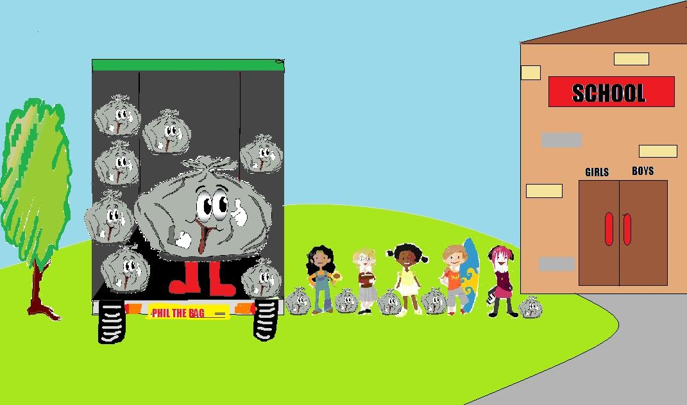

Don’t forget to bring in your bags of unwanted clothing, bags & shoes!
www.philthebag.co.uk

