

# Neston Primary School

## Church Rise

Neston

Corsham

**Wiltshire**

SN13 9SX

**Fax/🕾** 01225 810478

**email: admin@neston.wilts.sch.uk**

Head Teacher: Mrs Pam Evans B.A. (Hons) PGCE

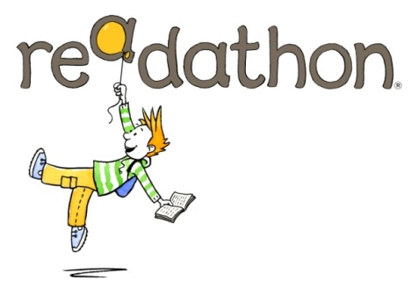***Where learning adventures begin…***

**Neston Festival of Reading 2014**

**Celebrating reading for pleasure:**

***anything, anytime, anywhere!***

Dear Parents / Carers

Today in assembly we launched our **Readathon Sponsored Read** and we’d like your child to join in. To get the Readathon off to a flying start we will be having a **Big Read** in assembly on **Wednesday 15th October** and all children are asked to bring in a book they can read or share with an older child.

**Readathon** is the UK’s national sponsored reading event for schools and is all about encouraging children to read for pleasure - an activity proven to increase children’s chances of success and personal happiness for the rest of their lives. *(Source: OECD)*

**Readathon** motivates children to read more books (comics, magazines etc) because:

* simply by reading, they will raise money for seriously ill children
* C:\Users\ta\AppData\Local\Microsoft\Windows\Temporary Internet Files\Content.IE5\A7UGAL7O\MC900232441[1].wmfthey’ll earn free books for their school worth 20% of their total sponsorship
* there are no set books or tests – they just read whatever they like

**Readathon** helps fund the important work of four UK children’s charities:

* **ReadWell** supplying free books and storytellers to children in hospital
* **CLIC Sargent** for children and young people with cancer and their families
* **Roald Dahl’s Marvellous Children’s Charity** for the seriously ill and disabled
* **Together for Short Lives** supporting children’s hospice services

There are **two easy things** you can do to help your child play an active part in our **Readathon** and make the school’s campaign a success - to everyone’s benefit:

1. **Take an interest in your child’s Readathon reading challenge**

They’ve been given a **Readathon** sponsorship card on which to list whatever they will enjoy reading. Books, e-books, comics, magazines, cereal packets – anything goes! Sharing a book with an adult or listening to an audio book is fine too.

1. **Help your child find sponsors among family and friends**

Please also encourage UK tax payers to tick the GiftAid box and fill in their name and address as instructed on the card. **Readathon** will then be able to claim an extra 25% from the Government at no cost to the donor.

Please ensure your child returns his/her sponsorship card and money before our **Readathon** closing date: **Friday 7th November.**

**Thank you for your support – and happy reading!**

Mrs Stansfield