Neston Primary School
Creative Curriculum Theme Plan Year 2
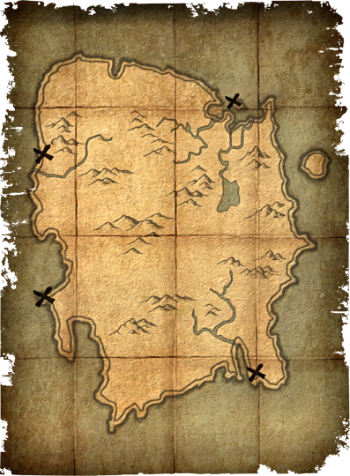  Term 1-2: The Sky’s the Limit  Dinosaur Island  Dinosaur Island |  |  |  |  | Areas of Learning
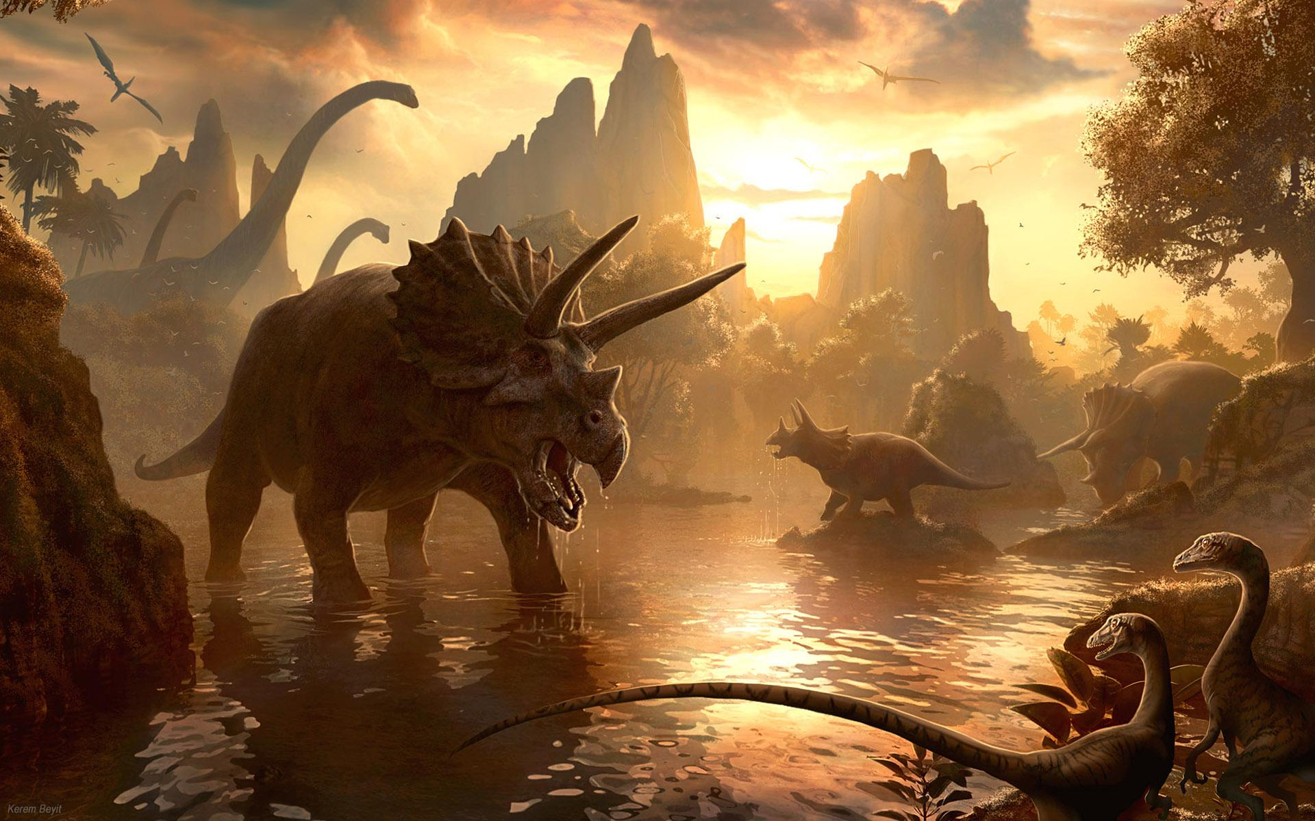  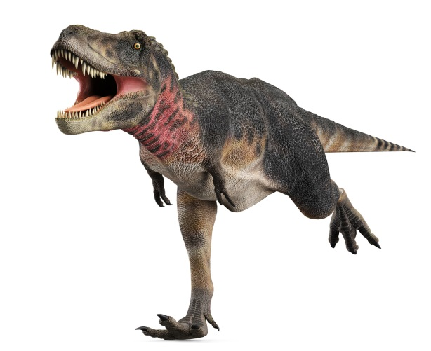 |  |  |  |  | Our learning will take inspiration from the book ‘Tom and the Island of the Dinosaurs’ We shall look at how the world has changed from the dawn of time and ask ourselves what is it possible to achieve and where might we adventure next.  As readers and writers, we shall be writing letters, compiling fact files about dinosaurs and writing a fictional story based on the book ‘Tom and the Island of the Dinosaurs.  As mathematicians we shall be measuring and using vocabulary to describe position and grid references for the map we make of ‘Dinosaur Island’  As Geographers, we shall be learning about how the world was formed, the continents and climates around the world. We shall also try and position Dinosaur Island somewhere on the globe based on its climate.  As artists and designers we shall illustrate plant, seeds and leaves that we examine in science. We shall also explore tone and line while creating a ‘treasure map’ of Dinosaur Island .
At Neston, learning will be driven by:
Ambition | Respect |  | Diversity
As ambitious learners we will:  Understand when we have been successful and aim ever higher to achieve our best.  . | As respectful learners we will:  Respecting the right of others to have beliefs and values different from their own. |  | As learners we will:  Learn about the diversity across the globe as we travel in our imaginary balloon to Dinosaur Island.
Core Learning Skills |  | Successful Learner Skills |  | Essential Learning Objectives
Literacy |  | - Knowing and understanding what, how and why I am learning  - Enjoy exploring, discovering and  unlocking our hidden treasures  - Knowing that we shine and reach the stars  - Learning from our mistakes  - Knowing how to improve and being resilient  - Looking after each other  - Learning reciprocally  - Celebrating everyone’s achievements  - Imagining, dreaming and believing for ourselves and others |  | History, |  |  | Geography
- Write letters and describe the format letters take  - Learn how to present information: write labels, captions, glossaries  - Write stories in imaginary settings |  |  |  | - Describe historical events  - To investigate and interpret the past  - To build an overview of world history  - To understand chronology |  | - To investigate places  - To investigate patterns  - To communicate geographically
Maths |  |  |  | Science |  |  | Design Technology
- Recognise the place value of each digit in a two-digit number (tens, ones)  - Understand and use terms and vocabulary associated with position, direction and movement; Measure lengths using uniform units; Begin to measure in centimetres and metres  - Partition numbers in different ways (for example, 23 = 20 + 3 and 23 = 10 + 13 |  |  |  | - To understand Find out and describe how plants need water, light and a suitable temperature to grow and stay healthy.  - Observe and describe how seeds and bulbs grow into mature plants  - To work scientifically |  | - Design, make and improve  Apply practical skills to design, make and improve products safely, taking account of users and purposes.  - To design, make, evaluate and improve  Design products that have a clear purpose and an intended user
 |  | RE, PSHE, PE,
- Show an understanding that one’s own behaviour affects other people.

- To Imagine: develop ideas with help and respond to the ideas of others then act on some ideas

- Describe some of the teachings of a religion.

- In PE we shall use dance to communicate a mood feeling or idea

ICT |  |  |  | Art, |  |  | Music
- Ongoing use of ICT to support research |  |  |  | - To develop ideas  - To refine techniques  - To respond to ideas and starting points.  - To explore ideas and collect visual information. |  | - To perform  - To compose  - To transcribe  - To describe music

