Neston Primary School
Creative Curriculum Theme Plan Y5/6
Terms 1 & 2 (2015/16) : The Sky’s the Limit |  |  |  |  |  |  |  | Areas of Learning
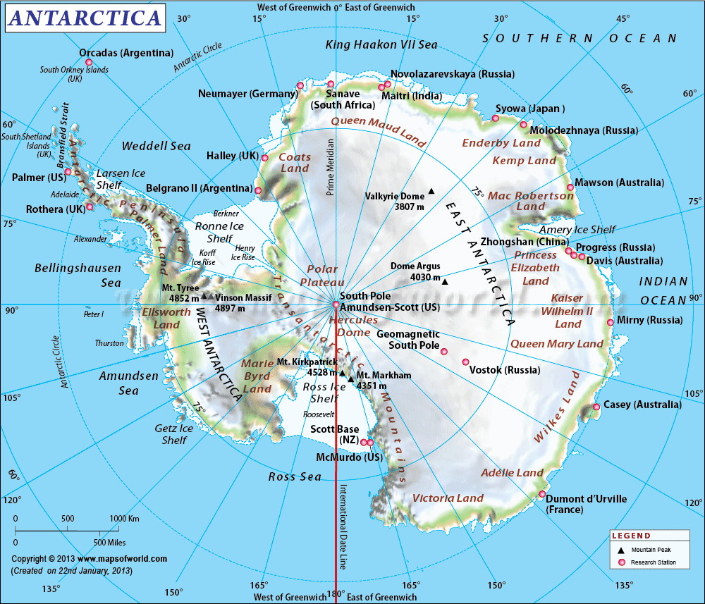  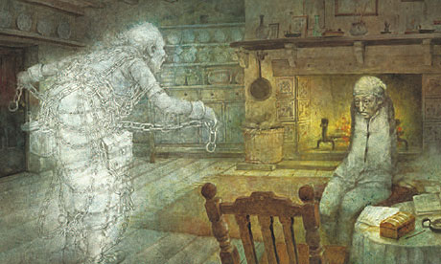  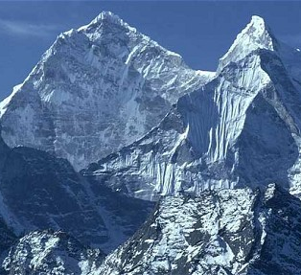  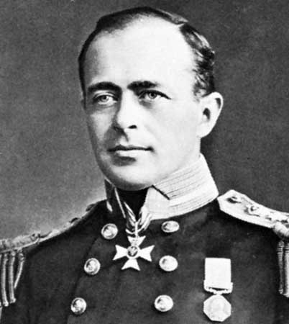  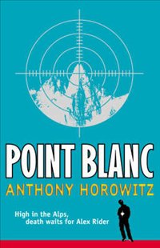  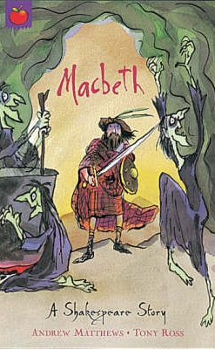  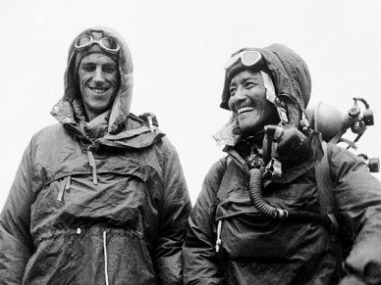  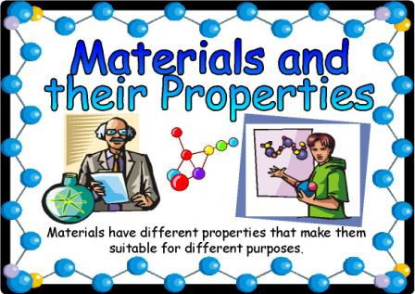  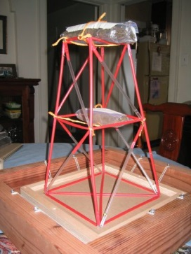  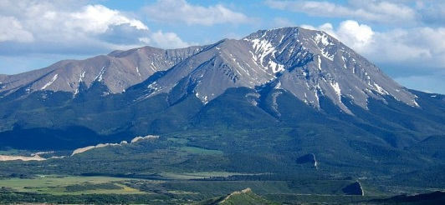 |  |  |  |  |  |  |  | As Historians and Geographers, we will learn about: mountains and their formation; the continent of Antarctica and Scott’s renowned expedition there; the first successful climb of Everest by Edmund Hilary and Tenzing Norgay and where these events fit onto a timeline.  As Readers and Authors, we will study a biography of Captain Scott and his race to the South Pole against Amundsen, as well as effective ways to produce newspaper texts about noteworthy events. Other important aspects of our literacy will include Shakespeare’s ‘Macbeth’, Charles Dickens’ ‘A Christmas Carol’ and Anthony Horowitz’s ‘Point Blanc’.  As Artists, we will create models showing mountain formations, linking to our geographical study. We will incorporate music and image into soundscapes based on Antarctica as well as improving our drawing skills using pencil.
At Neston, learning will be driven by:
Ambition | Respect |  | Diversity |  |  |  |  | As Scientists, we will...
As ambitious learners we will:  Explore what ambition means and what our own ambitions are, alongside ambitious challenges that others set themselves and why. | As respectful learners we will:  Learn to accept others views and decisions and respond in respectful ways. |  | As learners we will:  Embrace the range of ideas and beliefs that we all hold as individuals and learn how to respectfully respond to others as they challenge themselves and are challenged. |  |  |  |  | Investigate materials and their different properties, aiming to link their uses to specific properties. These ideas will link into the use of electricity and the basic ideas of structures taking weight and the forces involved.
Core Learning Skills |  | Successful Learner Skills |  | Key Skills (CQ level specific)
Literacy |  | - Knowing and understanding what, how and why I am learning  - Enjoy exploring, discovering and  unlocking our hidden treasures  - Knowing that we shine and reach the stars  - Learning from our mistakes  - Knowing how to improve and being resilient  - Looking after each other  - Learning reciprocally  - Celebrating everyone’s achievements  - Imagining, dreaming and believing for ourselves and others |  | History, geography and citizenship
- Structuring different genres of writing from biography, newspaper reports and poetry  - Presenting through play production and reciting poetry  - Reading and understanding a range of styles, both fiction and non-fiction  - Understanding and using aspects of grammar and spelling |  |  |  | Investigate  Undertake investigations and enquiries, using various methods, media and sources.  Ask relevant questions. |  |  | Analyse  Compare, interpret and analyse different types of evidence from a range of sources.  Recognise and describe change. |  |  |  | Communicate  Present and communicate findings in a range of ways and develop arguments and explanations using appropriate specialist vocabulary and techniques. |  |  | Consider and respond  Consider, respond to and debate alternative viewpoints in order to take informed and responsible action.
Maths |  |  |  | Science and design technology
- Compass directions linked to maps  - Scales on maps, height differences on maps  - Measuring and collecting data linked to science investigations  - Use of graphs to present data from investigations |  |  |  | Generate ideas  Observe and explore to generate ideas, define problems and pose questions in order to develop investigations. | Investigate, observe and record  Engage safely in practical investigations and experiments and gather and record evidence by observation and measurement. |  |  |  |  | Design, make and improve  Apply practical skills to design, make and improve products safely, taking account of users and purposes. |  | Explain  Communicate and model in order to explain and develop ideas, share findings and conclusions. |  |  | Evaluate  Make systematic evaluations when designing, making and investigating, to bring about improvements in processes and outcomes.
 |  | RE, PSHE, P4C, PE, MFL
In RE/PSHE/P4C we will be linking belief and ambition and exploring how these affect the choices that people make.

PE with Mr Johns – football and gymnastics
PE with class teachers - netball and dance
Spanish with Ms Keene

ICT |  |  |  | Art, music, drama
- Use of e-books for research  - Moviemaker to produce layered sound and image related to Antarctica  - Use of basic programming to control pathways |  |  |  | Explore  Explore, investigate and experiment from a range of stimuli and starting points, roles, techniques, approaches, materials and media. |  | Create  Create, design, devise, compose and choreograph individual and collective work. |  |  | Improvise  Improvise, rehearse and refine in order to improve their capability and the quality of their artworks. |  |  |  | Present  Present, display and perform for a range of audiences, to develop and communicate their ideas and evoke responses. |  | Evaluate  Use arts-specific vocabulary to respond to, evaluate, explain, analyse, question and critique their own and other people’s artistic works.

