Neston Primary School
Creative Curriculum Theme Plan Year1 – Terms 1 and 2 2015
The Sky Is The Limit |  |  |  |  |  | Areas of Learning
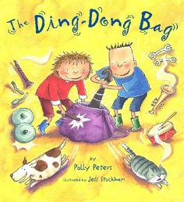  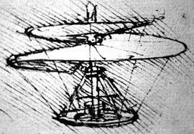  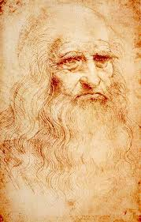  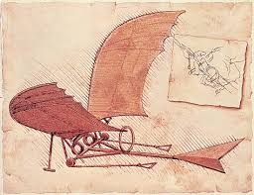  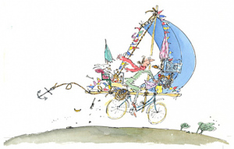  Inventors and their inventions  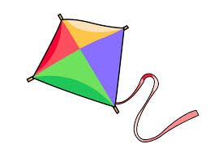  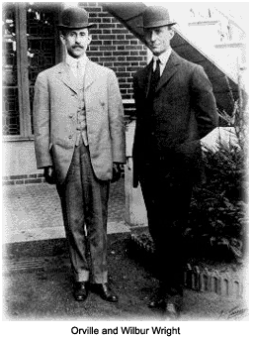  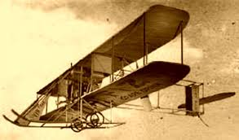  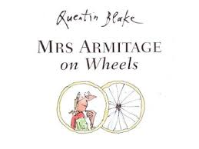 |  |  |  |  |  | As Historians, we will learn about inventions. We will use a variety of sources to find out about significant inventors from the past and the changes to daily lives resulting from their inventions.  As Readers and Writers, we will study non-fiction texts and traditional stories using story making techniques and repetitive language. We will write our own stories modelled on these tales. We will use and write non-fiction texts and labels to help us find and share facts.  As Artists and Designers, we will explore painting and mark making tools. We will use different techniques and materials to create models and images that support our understanding of inventions.
At Neston, learning will be driven by:
Ambition | Respect |  | Diversity |  |  | As Scientists, we will...
As ambitious learners we will:  Persevere with new skills and class routines. We will try new things and have a go at our own ideas. We will persist with an activity when challenges occur and be proud of our accomplishments. | As respectful learners we will:  Explore the similarities and differences between ourselves and others. We will learn to share our classroom space and resources fairly. |  | As learners we will:  Ask questions to help us understand the wider world in an open minded way. We will celebrate the range of culture, belief and experience that we explore. |  |  | Be exploring forces. We will discover how to use a force to make objects move, change their shape or change direction.
Core Learning Skills |  | Successful Learner Skills |  | Essential Learning Objectives (CQ milestone specific)
Literacy |  | - Knowing and understanding what, how and why I am learning  - Enjoy exploring, discovering and  unlocking our hidden treasures  - Knowing that we shine and reach the stars  - Learning from our mistakes  - Knowing how to improve and being resilient  - Looking after each other  - Learning reciprocally  - Celebrating everyone’s achievements  - Imagining, dreaming and believing for ourselves and others |  | History and geography
- Exploring labels and captions to develop our non-fiction writing  - Further develop our understanding of Phonics through daily teaching sessions and home learning  - Use story-making to develop our story telling, speaking, reading and writing skills |  |  |  | To investigate and interpret the past  To build an overview of world history  To understand chronology  To communicate historically |  |  | To investigate places  To investigate patterns  To communicate geographically
Maths |  |  |  | Science and design technology
- Further develop our understanding of number  - Explore calculation strategies and apply these in a range of role play and problem solving contexts  - Use data handling skills to share information |  |  |  | To understand movement and forces  To work scientifically |  |  | To design, make and improve  - Apply practical skills to design, make and improve products safely, taking account of users and purposes  To design, make, evaluate and improve our own inventions  - Design products that have a clear purpose and an intended user
 |  | RE, PSHE and PE
Exploring friendship and kindness. Learning appropriate ways to express and manage feelings.

Learning new class routines. Becoming a considerate and responsive partner, listening carefully and sharing ideas.

PE with Ms Sims - exploring movement through games activities.

ICT |  |  |  | Art, music, drama
- Ongoing use of ICT to support learning across the curriculum  - Use of the school website and class web page to share our learning |  |  |  | To develop ideas  To refine techniques  To respond to ideas and starting points.  To explore ideas and collect visual information. | To perform  To compose  To transcribe  To describe music |  |  | To listen carefully and understand  To speak with clarity  To tell and share stories with structure

