25.10.13 Turing Home Learning
Next week your test will be on finding fractions of whole numbers, for example 6/7 of 63, ¾ of 36, 3/8 of 72. You all know your tables well so work on the speed of doing the two stages of calculating that these need. You need a partner.
Use the multiplication square – choose any number, then go vertically up to see which times table it is in, use that number as your denominator (the number on the bottom of the fraction). Then get your partner to choose a number that is between that number and 1, use this number as your numerator (the number on the top of your fraction). Now find the fraction that you have created of your original number. If you are correct you can cover the square, now your partner has a go. Your aim is to get 4 in a row.

This is an activity on the ‘nrich’ website to practise your dividing and your reasoning – have a go for fun!! http://nrich.maths.org/6402

25.10.13 Noether Home Learning
Next week your test will be on finding fractions of whole numbers, for example 1/7 of 63, ¼ of 36, 1/8 of 72. You all know your tables well, so work on the speed of calculating these fractions. You need a partner.
Use the multiplication square – choose any number, then either go vertically up or horizontally to the left, to see which times table it is in, use that number as your denominator (the number on the bottom of the fraction). Your numerator (the number on the top of your fraction) is always 1. Now find the fraction that you have created of your original number. E.g. I choose 24, then choose to go up vertically to 3, that is my denominator, I now to find 1/3 of 24. If you are correct you can cover the square, now your partner has a go. Your aim is to get 4 in a row.

Multiplication square

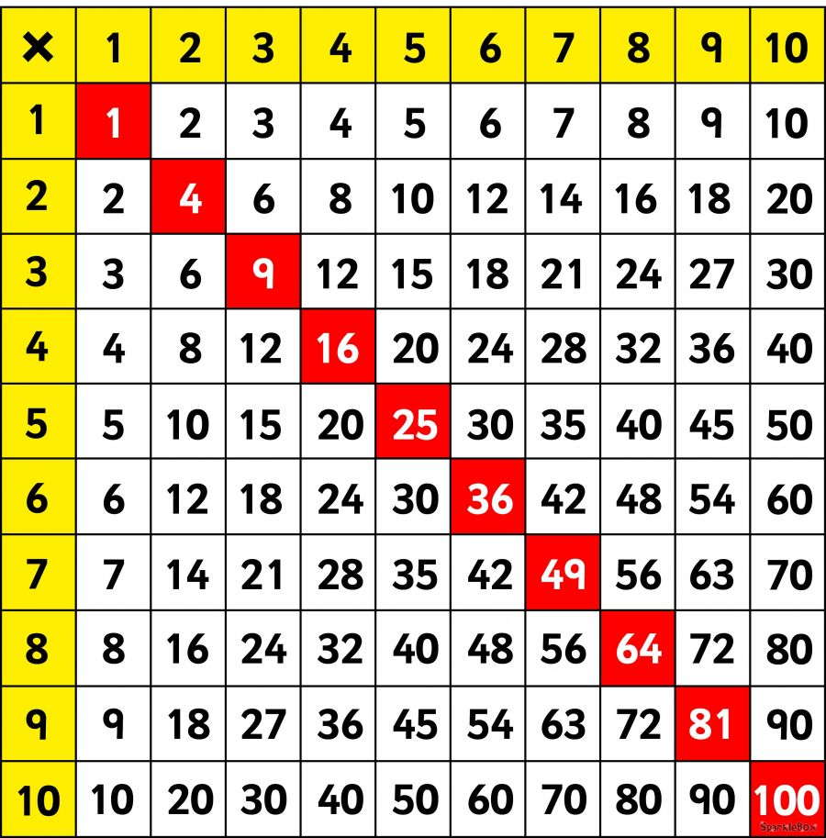

25.10.13 Newton Home Learning
Your test after the holiday will be on simplifying fractions; so using your knowledge of common multiples, factors and multiplication patterns to recognise the quickest ways to simplify fractions.
Remember that you have to divide the numerator and the denominator by the same number to simplify the fraction.
To practise, use this activity on your own or with a partner. You will need the hundred square and a die (0-9 if you have one, otherwise 1-6).
Choose any number on the hundred square, then roll the die. The number on the die is your hundreds number that goes in front of the number you have chosen from the board. E.g. I chose 46 and rolled 5, so my number is 546. Repeat that to generate another number, e.g. I chose 22 and rolled 1, so my number is 122. You then use the smallest number as your numerator and the biggest number as your denominator and create a fraction with them. E.g. 122
546
Then you need to simplify the fraction as far as you can so that it ends up in its simplest form.

