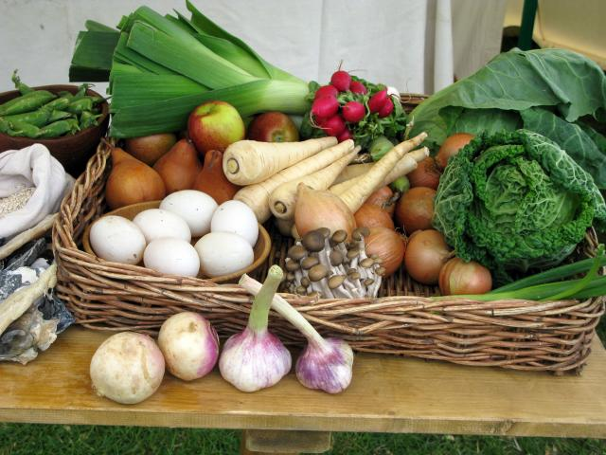

Beech and Maple Home Learning Project

Set on 8.11.13 and due to be completed by …

Research which fruits and vegetables were eaten in Britain in medieval times. Choose one to investigate further and find out the different ways it was used in cooking or in baking. Find a recipe that features your chosen fruit or vegetable and was eaten in the middle ages. Your task is to make a medieval dish (you may want to test the recipe out once before bringing it in to share with everyone) for the afternoon of our Christmas party (date)!

The success criteria for this task are:

1. Your food needs to be edible!
2. Please provide a hand written recipe page (with medieval-style illustrations) to accompany your dish. (We will create a medieval recipe book from all of your contributions.)
3. And finally, please complete the attached form to evaluate your culinary creation.

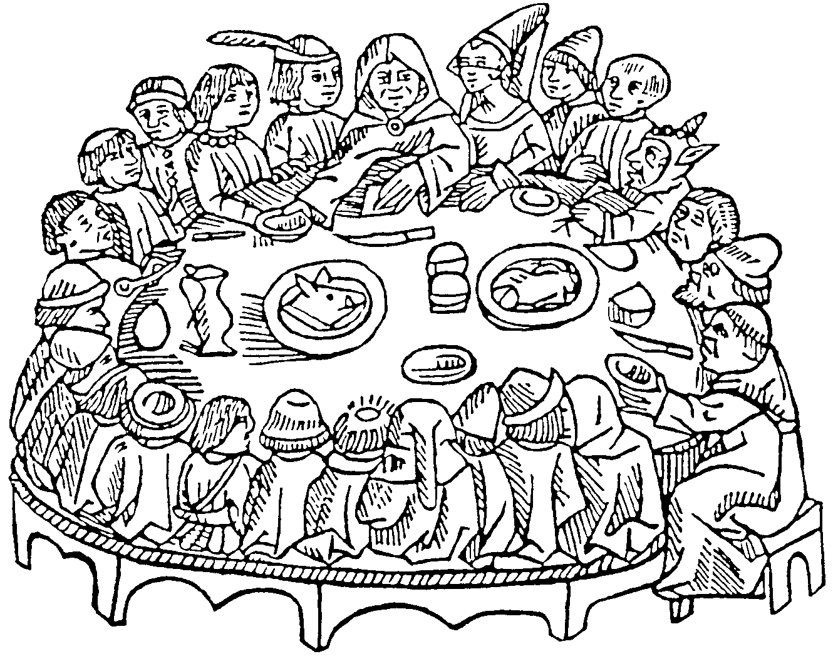

|  |
| --- |
| During this project I learnt how to: |
| I was really pleased with: |
| I had some problems like: |
| I sorted them out by: |
| Next time I would: |

**Medieval Cooking Evaluation**

