Beech and Maple Home Learning Project – October 2014

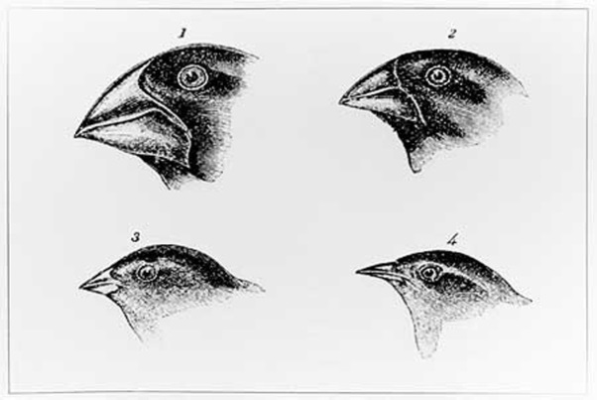
Task: to produce a poster, A4 size, on Charles Darwin’s ‘Theory of Evolution’.

Here are some tips to help you.
- This is an enormous area so choose just one or two elements of it to explore on your poster, and use examples to help.
- Use books and the internet to help you. (If you are stuck ask your teacher for support before it is too late!)
- Give examples of evidence that could be used to support his theory. Think about what we have learnt about at school – birds, and fossils in particular.
- Use the correct scientific vocabulary. Include words such as adaptation, variation, inheritance.
- Do not talk about his life in general, only his theory.
- Use images that link to your writing.
- Use a computer if you want to.
- Use clear, precise language. You want others to be able to learn from your poster.
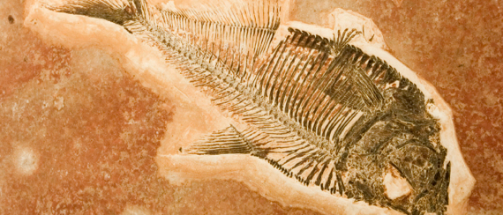

Your posters need to be in by Monday 17th November. They will be forming part of a display so presentation is important.

